# 

**Name:** Puneet Sehdev

**Branch:** Mechanical Engineering

**Section-** ME B1  **Roll Number:** 2030070

|  |  |  |  |
| --- | --- | --- | --- |
| S.No | PROJECT NAME | DATE | TEACHER SIGN |
| 1 | Program to print favorite Poem |  |  |
| 2 | Program to do arithmetic calculation |  |  |
| 3 | Program to use different types of data types  (Floats and Integers) |  |  |
| 4 | Program to use logical Operators |  |  |
| 5 | Program to use relational Operators |  |  |
| 6 | Program to use Increment and Decrement Operators |  |  |
| 7 | Program to use If-else, If else ladder |  |  |
| 8 | Program to for loop, nested for loop |  |  |
| 9 | Program to use while loop, do while loop |  |  |
| 10 | Program to use switch (Break & Continue) |  |  |
| 11 | Program to display student info. Using structure |  |  |
| 12 | Fibonacci series |  |  |
| 13 | Factorial |  |  |
|  |  |  |  |
|  |  |  |  |
|  |  |  |  |
|  |  |  |  |
|  |  |  |  |
|  |  |  |  |
|  |  |  |  |
|  |  |  |  |
|  |  |  |  |
|  |  |  |  |
|  |  |  |  |
|  |  |  |  |
|  |  |  |  |
|  |  |  |  |
|  |  |  |  |
|  |  |  |  |
|  |  |  |  |
|  |  |  |  |
|  |  |  |  |
|  |  |  |  |
|  |  |  |  |
|  |  |  |  |
|  |  |  |  |
|  |  |  |  |
|  |  |  |  |

# Practical Number - 1

**Practical Name -** **Program to print favorite Poem**

**Practical code**

#include <stdio.h>

int main()

{

printf(" ME B1, Roll No. - 2030070, Display favourite poem\n\n");

printf("Favourite Poem- Poem Johney Johney \n\n");

printf("Johney Johney,Yes papa!\n");

printf("Eating sugar,No papa!\n");

printf("Telling lie,No papa!\n");

printf("Open Your mouth, Ha Ha Ha!");

return 0;

}

# Output

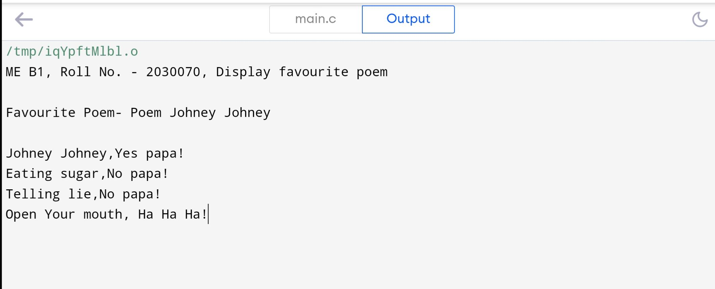

**Practical number - 2**

**Practical Name - Program to do arithmetic calculation**

**Practical code**

#include <stdio.h> int main()

{

int a, b, sum; a=12;

b=25;

sum=a+b;

printf("ME B1, Roll no= 2030070, Adding two integers\n");

printf("Sum of two number is %d",sum);

return 0;

}

# Output

**Practical number -3**

**Practical Name - Program to use different types of data types**

**(Floats and Integers)**

**Q. Write a C program to compute the perimeter and area of a circle with a radius of 6**

**inches.**

**Practical Code**

#include <stdio.h>

int main()

{

int radius;

float area, perimeter;

radius = 6;

perimeter = 2*3.14*radius;

printf("Perimeter of the Circle = %f inches\n", perimeter);

area = 3.14*radius*radius;

printf("Area of the Circle = %f square inches\n", area);

return(0);

}

**Output**

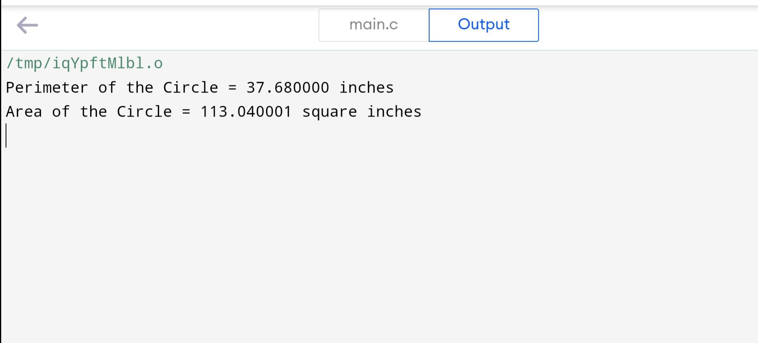

**Practical number -4**

**Practical Name - Program to use logical Operators**

**Practical Code**

#include <stdio.h>

int main()

{

int a = 5, b = 5, c = 10, result;

printf("ME B1, Roll no= 2030070, Program to use logical Operators\n");

result = (a == b) && (c > b);

printf("(a == b) && (c > b) is %d \n", result);

result = (a == b) && (c < b);

printf("(a == b) && (c < b) is %d \n", result);

result = (a == b) || (c < b);

printf("(a == b) || (c < b) is %d \n", result);

result = (a != b) || (c < b);

printf("(a != b) || (c < b) is %d \n", result);

result = !(a != b);

printf("!(a != b) is %d \n", result);

result = !(a == b);

printf("!(a == b) is %d \n", result);

return 0;

}

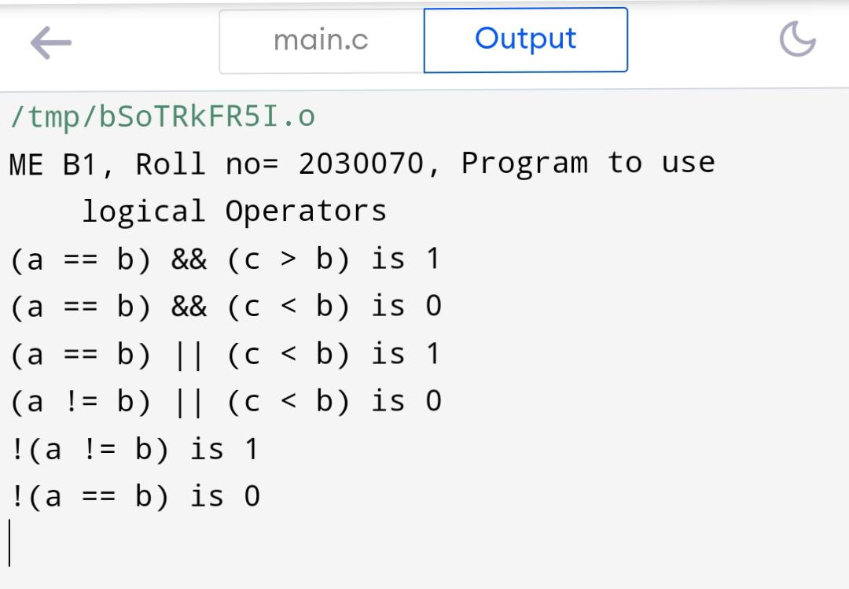**Output**

**Practical number -5**

**Practical Name - Program to use relational Operators**

**Practical Code**

#include <stdio.h>

int main()

{

int a = 5, b = 5, c = 10;

printf("ME B1, Roll no= 2030070, Program to use relational Operators\n");

printf("%d == %d is %d \n", a, b, a == b);

printf("%d == %d is %d \n", a, c, a == c);

printf("%d > %d is %d \n", a, b, a > b);

printf("%d > %d is %d \n", a, c, a > c);

printf("%d < %d is %d \n", a, b, a < b);

printf("%d < %d is %d \n", a, c, a < c);

printf("%d != %d is %d \n", a, b, a != b);

printf("%d != %d is %d \n", a, c, a != c);

printf("%d >= %d is %d \n", a, b, a >= b);

printf("%d >= %d is %d \n", a, c, a >= c);

printf("%d <= %d is %d \n", a, b, a <= b);

printf("%d <= %d is %d \n", a, c, a <= c);

return 0;

}

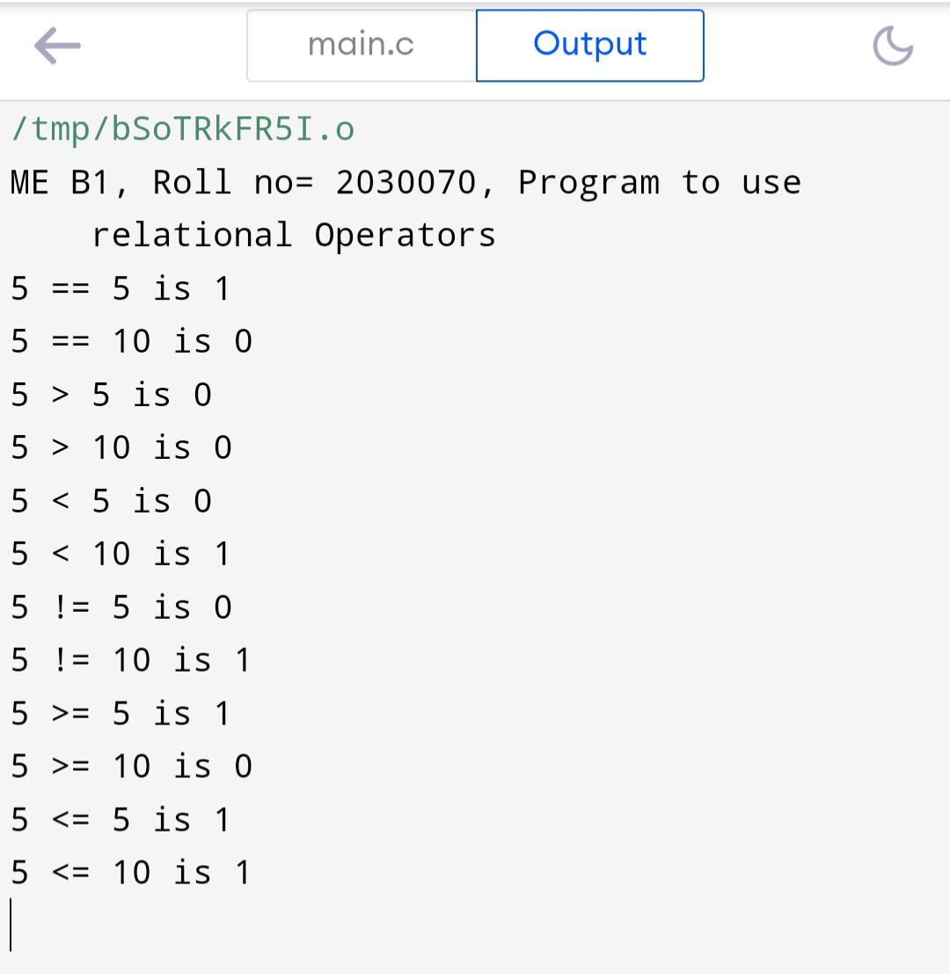**Output**

**Practical number -6**

**Practical Name - Program to use Increment and Decrement Operators**

**Practical Code**

#include<stdio.h>

int main()

{

int x = 12, y = 1;

printf("ME B1, Roll no= 2030070,Program to use Increment and Decrement Operators\n");

printf("Initial value of x = %d\n", x);

printf("Initial value of y = %d\n\n", y);

y = ++x;

printf("After incrementing by 1: x = %d\n", x);

printf("y = %d\n\n", y);

y = --x;

printf("After decrementing by 1: x = %d\n", x);

printf("y = %d\n\n", y);

return 0;

}

**Output**

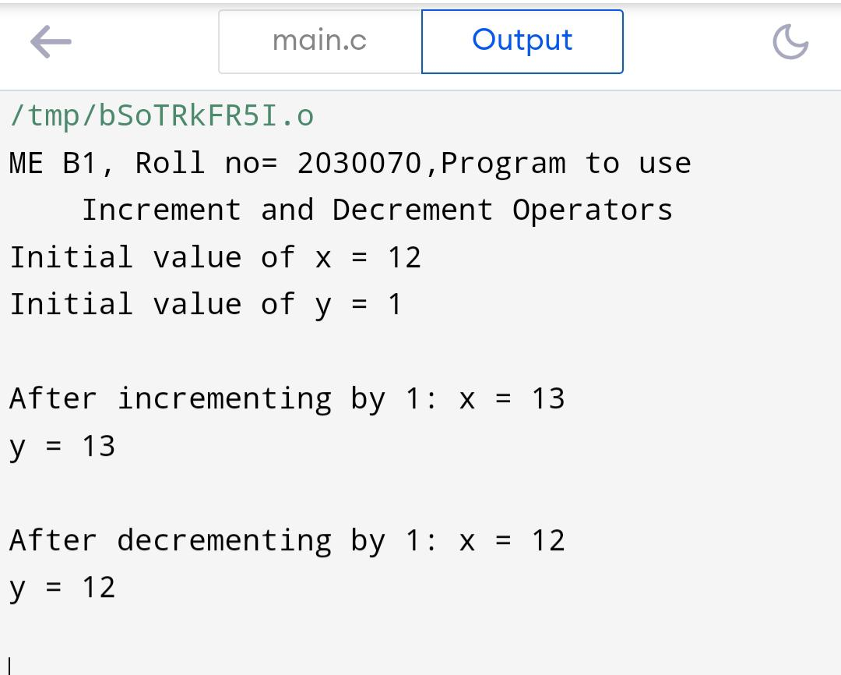

**Practical number -7**

**Practical Name - Program to use If-else, If else ladder**

**Q. Write a program to find largest number given by user.**

**Practical Code**

#include<stdio.h>

int main()

{

int a,b,c;

printf("ME B1, Roll no= 2030070,- Program to use If-else, If else ladder\n");

printf("Enter three numbers: \n");

scanf("%d%d%d", &a, &b, &c);

if(a>b && a>c)

{

printf("Largest = %d", a);

}

else if(b>a && b>c)

{

printf("Largest = %d", b);

}

else

{

printf("Largest = %d", c);

}

return (0);

}

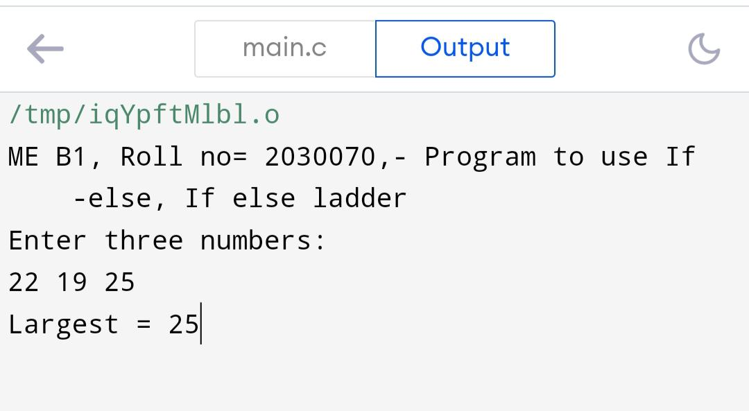**Output**

**Practical number -8**

**Practical Name - Program to for loop, nested for loop**

**Q.** Write a program which uses a nested for loop to find the prime numbers from 2 to 100

**Practical Code**

#include <stdio.h>

int main () {

int i, j;

printf("ME B1, Roll no= 2030070,Program to for loop, nested for loop\n");

for(i = 2; i<100; i++)

{

for(j = 2; j <= (i/j); j++)

if(!(i%j)) break; // if factor found, not prime

if(j > (i/j)) printf("%d is prime\n", i);

}

return 0;

}

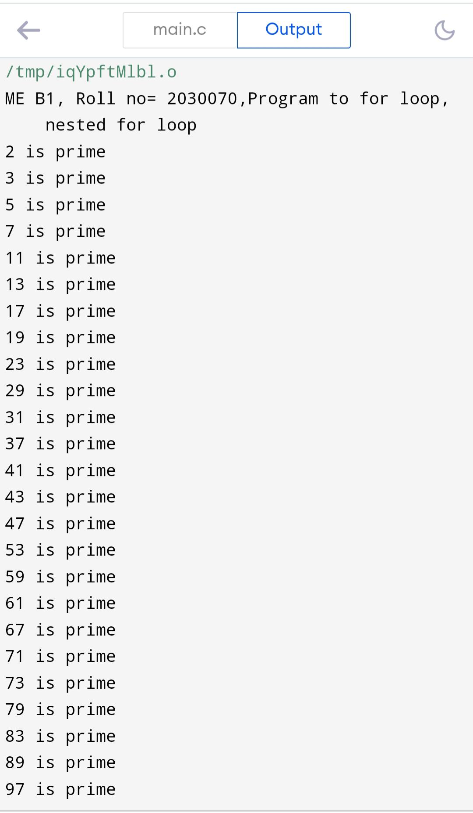 **Output**

**Practical number -9**

**Practical Name - Program to use while loop, do while loop**

**Practical Code**

// Program to add numbers until the user enters zero

#include <stdio.h>

int main()

{

double number, sum = 0;

// the body of the loop is executed at least once

do

{

printf("Enter a number: ");

scanf("%lf", &number);

sum += number;

}

while(number != 0.0);

printf("Sum = %.2lf",sum);

return 0;

}

**Output**

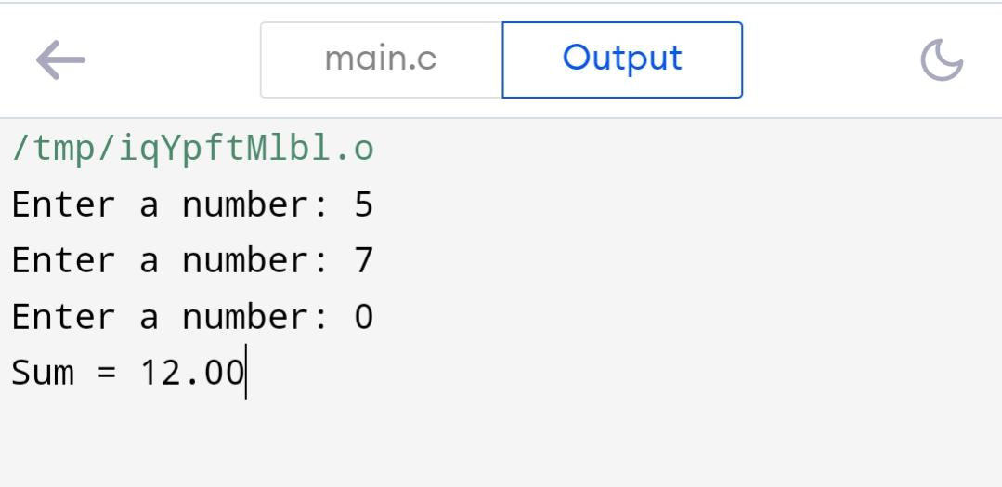

**Practical number -10**

**Practical Name - Program to use switch (Break & Continue)**

**Practical Code**

// Program to calculate the sum of numbers (10 numbers max)

// If the user enters a negative number, the loop terminates

#include <stdio.h>

int main() {

int i;

printf("ME B1, Roll no= 2030070,Program to use switch (Break & Continue)\n");

double number, sum = 0.0;

for (i = 1; i <= 10; ++i) {

printf("Enter a n%d: ", i);

scanf("%lf", &number);

// if the user enters a negative number, break the loop

if (number < 0.0) {

break;

}

sum += number; // sum = sum + number;

}

printf("Sum = %.2lf", sum);

return 0;

}

**Output**

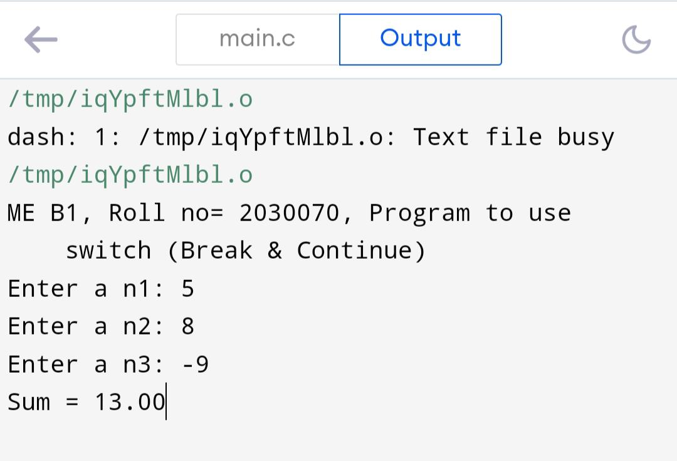

**Practical number -11**

**Practical Name - Program to display student info. Using structure**

**Practical Code**

#include <stdio.h>

struct student

{

char name[50];

int roll;

float marks;

};

int main()

{ //Nisha

struct student s;

printf("Enter The Information of Students :\n\n");

printf("Enter Name : ");

scanf("%s",s.name);

printf("Enter Roll No. : ");

scanf("%d",&s.roll);

printf("Enter marks : ");

scanf("%f",&s.marks);

printf("\nDisplaying Information\n");

printf("Name: %s\n",s.name);

printf("Roll: %d\n",s.roll);

printf("Marks: %.2f\n",s.marks);

return 0;

}

**Output**

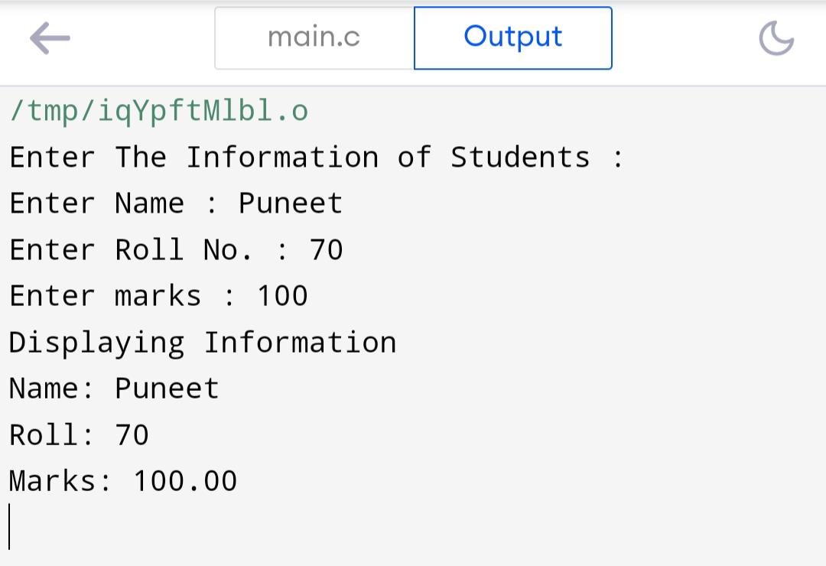

**Practical number -12**

**Practical Name – Fibonacci series**

**Practical Code**

#include <stdio.h>

int main ()

{

int i,total,t1=0,t2=1,next;

printf("ME B1, Roll no= 2030070,Program for Fibonacii series\n");

printf("enter the number of terms\n");

scanf("%d", &total);

printf("Fibonacii series");

for (i=1; i<=total; i++)

{printf("%d", t1);

next=t1+t2;

t1=t2;

t2=next;

}

return 0;

}

**Output**

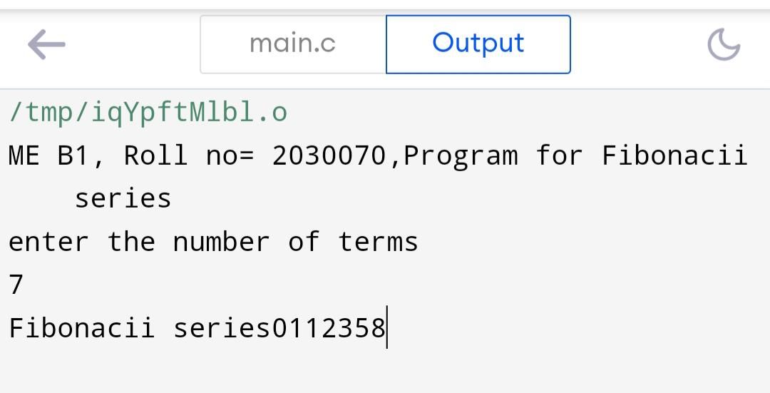

**Practical number -13**

**Practical Name – Factorial**

**Practical Code**

#include <stdio.h>

int main()

{

int i, number;

int fact=1;

printf("ME B1, Roll no= 2030070\n");

printf("Enter the value of integer: \n");

scanf("%d", &number);

for(i=1;i<=number; i++)

{

fact=fact*i;

}

printf("Factorial of %d is:%d", number , fact);

return 0;

}

**Output**

